**Q1: Have you ever created a visualization of data?**

Yes, as a part of my previous job as a Business Intelligence developer in one of the utilities firms I was responsible for developing various visualization reports of the business for the management.

The tool used was Oracle BI suite. OBIEE is a commercial tool by Oracle for performing business intelligence and producing and delivering enterprise reports, dashboards, scorecards, OLAP analysis, and ad-hoc analysis.

The data consisted of various utilities (Electricity and Gas supply) related information like the usages, business earnings per quarter, the spending of individuals, resource utilization etc. All this data was collected through various OLTP systems using different data warehousing tools. The visualizations produced consisted of graphs, pie-charts, and tables for top values. Examples would be graphs describing relations between usages and spending of customers of regions, pie-charts showing earnings through various sources etc.

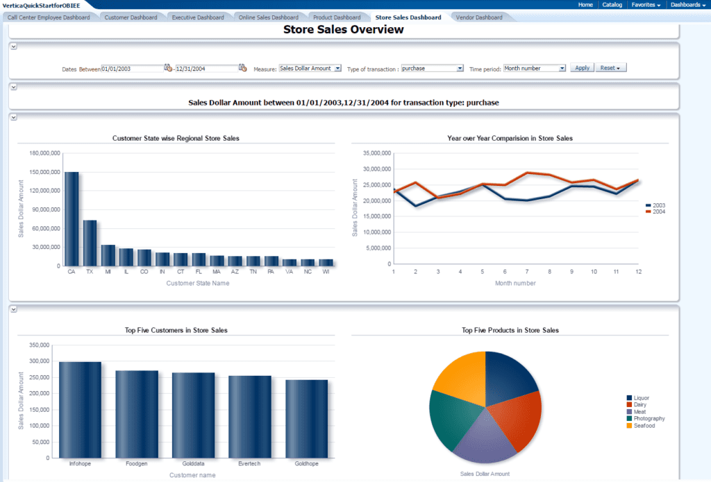

(Actual project image not accessible, Reference OBIEE image taken from internet)

Source: <https://www.vertica.com/quickstart/vertica-quickstart-obiee/>

**Q2: Describe some complex dataset or data source (e.g. it could be streaming real-time data) that could benefit from visualization.**

A real-time data for resource utilization of a large system (like AWS / Google cloud / Or any cluster farm) would benefit immensely from visualization. This data source could be a huge volume of system logs being generated continuously. A visualization system that gives information of overall system just at a glance could save many hrs of manual labor for analyzing issues in the system. We can quickly identify for example if there is any process that is utilizing system resource more than usual and take appropriate actions. The real-time prediction can be made for example of hardware failure based on different parameters.

There are many visualization strategies that can be applied to this kind data set depending on the application and use case. Mostly bar graphs to visualize trends, line charts for error/utilization spikes , heat maps to show traffic congestions in network etc.. can be thought of.

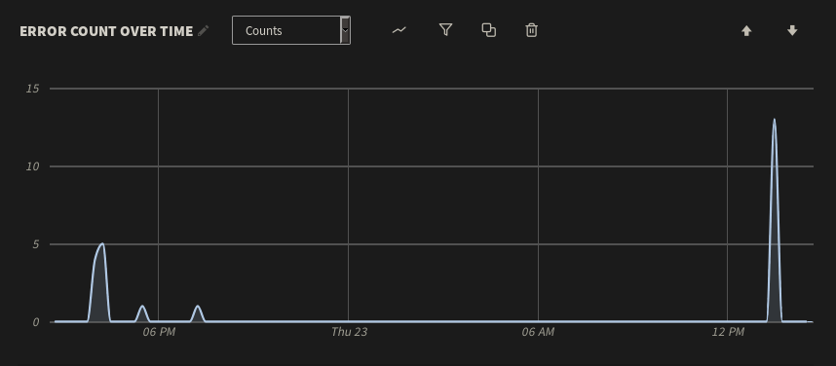 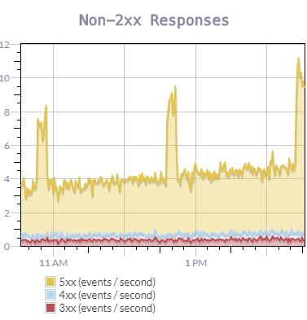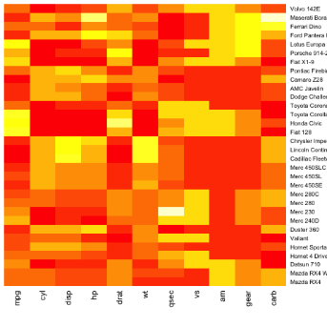

Source: <https://logdna.com/blog/how-to-visualize-your-log-data/>

<https://blog.scalyr.com/2017/12/surprising-use-cases-log-visualization/>